Suturing

By

Dr. Abdelrahman Mohammad Galal General surgery department

Suture Classification and Selection (Import)
t r l ifi ti
l ti
(I rt)

Classification of Sutures
l ssific ti f t r s
Monofilament | Multifilament
Synthetic | Biological
Absorbable | Non - Absorbable

The Ideal Suture (Import)
(I rt)

• Minimal tissue reaction

• Smoothness - minimum tissue drag • Low Capillarity
• Max tensile strength

• Ease of handling - Minimum memory • Knot security
• Cost effectiveness

Sutures
•
•ABSORBABLE

I * r i t r
•
I * t r
•
* t r
•
I * t r
•
* t r

•BIOLOGICAL •SYNTHETIC •BIOLOGICAL •SYNTHETIC
•
-
•NON-ABSORBABLE

•

•VICRYL* rapide Suture •MERSILK* Suture

•MONOCRYL* Suture
•
* t r

•Coated VICRYL* Suture
•
t I * t r

•MERSILENE* Suture •ETHIBOND* Suture
•
I * t r
•
I * t r
•
•PROLENE* Suture
* t r

•Coated VICRYL* Plus Suture
•
t I * l t r

•PDS*II Suture
•
*II t r
•PRONOVA* Suture •ETHILON* Suture •NUROLON* Suture
•Stainless Steel Wire
•
t i l t l ir

•Monofilament version VICRYL* Suture available for use in ophthalmic surgery •MERSILENE* Suture - trochanter suture is braided
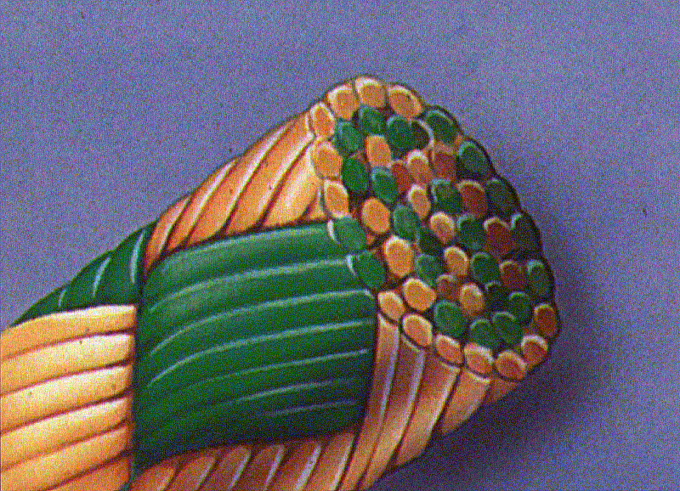
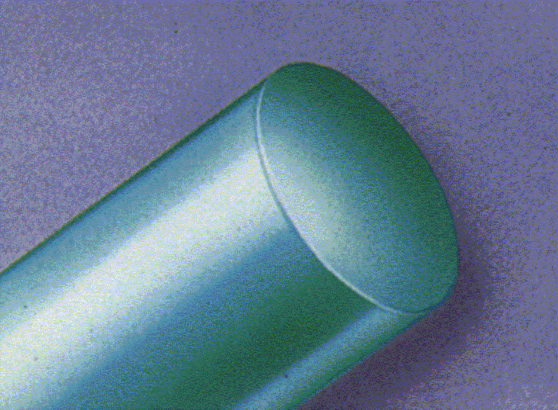
t r
l ifi ti

Suture

Monofilament
fil t
Classification

Multifilament (braided)
ltifil t ( r i )

Absorbable Sutures
s r l
t r s
) L I :

1) PLAIN GUT:
•Derived from the small intestine of healthy sheep.

2) CHROMIC GUT:
) I :
•Treated with chromic acid to delay tissue absorption time.

• Loses 50% of tensile strength by 5-7 days.

•50% tensile strength by 10 -14 days.

•Used on mucosal •Used in episiotomy repairs. surfaces.

3) Polyglycan 910 (Vicryl®)
)
l l c
( icr l )

•Braided •Synthetic polymer
•50% tensile strength for 30 days •Used: subcutaneous

4) Polydioxanone (PDS II)
)
l i x
( )

•A sterile synthetic •Absorbable •Monofilament suture
•Made from the polyester (polydioxanone.)
•PDS II sutures are intended for use in general soft tissue approximation, including use in paediatric cardiovascular tissue, in microsurgery, in ophthalmic surgery and Gastrointestinal anastomosis.
•Complete absorption occurs within 182 to 238 days.

Non-absorbable Sutures
- s r l
t r s

1) Polypropylene (Prolene®):
• Stronger than nylon and has better overall wound security.

•Non braided.
•Monofilament (no infection).

2)silk •braided
•Before the advent of synthetic fibers, silk was the mainstay of wound closure.

•workable and has excellent knot security.

Disadvantages: •high reactivity •infection

Monofilament Advantages Disadvantages
tails which could cause

•Smooth surface •Difficult Handling & knotting

•Less tissue trauma

•No bacterial harbours

•No capillarity
•more stiff and suture ends or discomfort.

•Stretchable

Multifilament

Advantages

• Strong and braided (like a
Rope)

• Soft & pliable

• Good handling

• Good knotting • Not slipping.

Disadvantages

•Bacterial harbours

•Capillary action >>>> infection strands
can travel within the suture

•Tissue trauma

Synthetic
The drawbacks are
(Synthetic materials are man – made, produced by industrial processes)

Advantages
Non-Absorbables are inert( no
tissue reaction)

•Absorbables resemble natural
substances

•Absorption by hydrolysis

•Predictable absorption

•Stronger than biological
Disadvantages •related to their structure

chemical composition.
rather than their

•More difficult to handle structure
in the monofilament

•Encapsulation can result
in the suture being

extruded or expelled by
the body.

Biological
i l ic l
(derived from naturally occuring sources such as animal / plant tissues)

Advantages Disadvantages

•Good Handling & •Tissue reactions knotting

•Economical

Note: Biological sutures are now only available in non – absorbables.

Characteristics of Non-Absorbable Sutures (Import)
(I rt)

•Permanent
•Only used when long term support is required •Removed when used for skin
•Tissue reaction generally low (except silk) •True non-absorbable sutures include polyester,
polyethylene, polypropylene and steel

Absorbable Advantages Disadvantages

•Broken down by body •Consideration of wound
support time

• No foreign body left support to sa tissuepfor. ias quickly, f it lrcould lead t to
(A suture must rovde
long as it’ necessary
If the sutu e absorbs oo
wound ai ure)

Non – Absorbable
s r l
( t ri ls ic r t r t , r i i i l c
r tl )
(materials which are not broken down by the body, remaining in place permanently)

Advantages

•wound Support
Permanent

Disadvantages

•Foreign body left in the body

•Suture removal can be costly and
inconvenient

•Wound Sinus (A sinus is a track communicating with an abscess and
the skin)

•Suture Extrusion if left in place

Suture Size

USP (United States Pharmacopoeia)

5..4..3..2..1..0..2/0..3/0..4/0..5/0..6/0..7/0..8/0..9/0..10/0..11/0 General

Thick Thin

Suture Selection (Import)
(I rt)

Bowel: 2/0 - 3/0 Fascia: 1 - 0 Skin: 2/0 - 5/0 Arteries: 2/0 - 8/0
Micro surgery 9/0 - 10/0 Corneal closure: 9/0 - 10/0

Needles

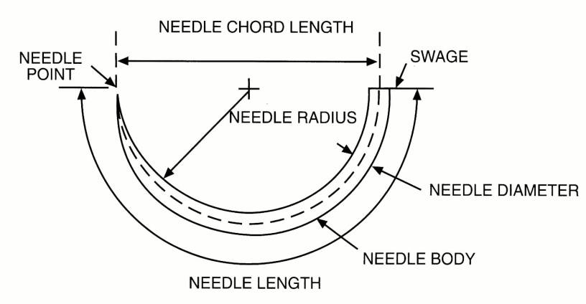
Anatomy of a Surgical Needle

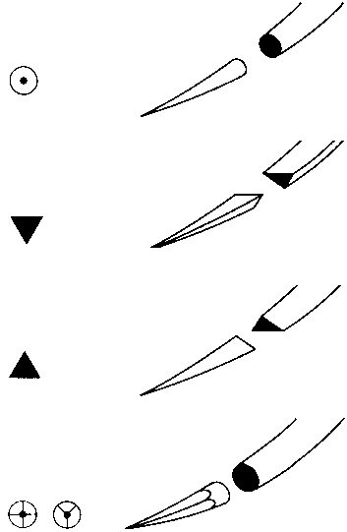
Needle point Geometry
 | Taper-Point | •Suited to soft tissue •Dilates rather than cuts
 | Reverse cutting | •Very sharp •Ideal for skin  •Cuts rather than dilates
 | Conventional Cutting | •Very sharp  •Cuts rather than dilates  •Creates weakness allowing suture tearout
 | Taper-cutting | •Ideal in tough or calcified tissues  •Mainly used in Cardiac & Vascular procedures.

l
i t tr

The ideal surgical needle should be
i l s r ic l l s l
1. Rigid enough to resist distortion,
2. Flexible enough to bend before breaking, 3. Slim as possible to minimise trauma,
4. Sharp enough to penetrate tissue with minimal resistance, and be
5. Stable within a needle holder to permit accurate placement.

Commonly, surgical needles are made from stainless steel. They are composed of:
The swaged end connects the needle to the suture

The needle body or shaft is the region grasped by the needle holder. Needle bodies can be round, cutting, or reverse cutting:

1. Round bodied needles are used in friable tissue such as liver and kidney
. i

2. Cutting needles are triangular in shape, and have 3 cutting edges to penetrate tough tissue such as the skin and sternum, and have a cutting surface on the concave edge
. tti l s

3. Reverse cutting needles have a cutting surface on the convex edge, and are ideal for tough tissue such as tendon or subcuticular sutures, and have reduced risk of cutting through tissue
. rs c tti

The needle point acts to pierce the tissue, beginning at the maximal point of the body and running to the end of the needle, and can be either sharp or blunt:

1. Blunt needles are used for abdominal wall closure, and in friable tissue, and can potentially reduce the risk of blood borne virus infection from needlestick injuries.

2. Sharp needles pierce and spread tissues with minimal cutting, and are used in areas where leakage must be prevented.

The needle shape vary in their curvature and are described as the proportion of a circle completed – the ¼, ⅜, ½, and ⅝ are the most common curvatures used.

Needle Shapes (read for MCQ)
•Eye •Microsurgery | •Nasal cavity •Nerve  •Skin •Tendon
•Dura •Eye •Fascia •Nerve | •Eye (Anterior • segment)
•Muscle •Eye •Skin  •Peritoneum | •Laparoscopy
•Cardiovascular •Oral
•Pelvis •Urogenital tract

•Needles are available in various shapes to accommodate the desired depth of bite and the desired "turnout" in specific tissue. The available shapes are shown on the slide.

•Selection of the needle shape is dependent on the size and depth of the area to be sutured. Use of the 1/4 circle needle is often limited to ophthalmic and microsurgical procedures.

•A commonly used curved needle is the 3/8 Circle. These needles can be easily manipulated in relatively large and superficial wounds such as closure of the dermis.

•Because a large arc of manipulation is required, 3/8 Circle needles can be awkward or impossible to use in deep cavities such as the pelvis or in other small difficult to access locations.

•A 1/2 Circle needle is relatively easy to use in these confined locations, although it requires more rotation of the wrist than a 3/8 circle.

•The tip of a 1/2 circle needle can become obscured by tissue deep in the pelvic cavity for example. When this occurs the surgeon may have difficulty locating the point to reposition the needle holder and pull the needle through tissue. A 5/8 Circle needle may be useful in this situation, as may a 'J' needle.

•Straight needles are generally used for skin and compound curved needles for Ophthalmics.

Suture Label

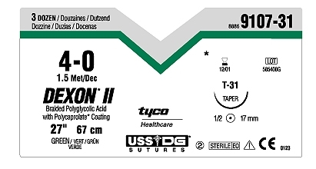
The Suture Packaging (Import)
t r
c i
(I rt)

STRAND SIZE

MATERIAL

STRAND LENGTH
PRODUCT CODE

NEEDLE CODE WITH LIFE SIZE PICTURE OF NEEDLE

NEEDLE COLOUR CIRCLE
POINT NEEDLE TYPE LENGTH

Common Suture Techniques
t r
c i s

1. Simple Interrupted
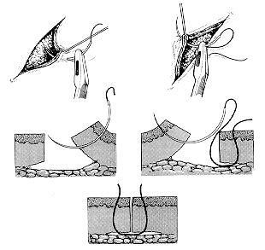
•Used on majority of wounds •Each stitch is independent

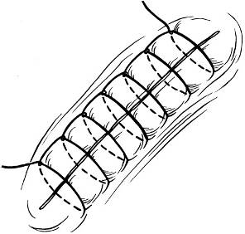
Suture Techniques

2. Simple Continuous •Useful in pediatrics
•Rapid
•Easy removal
•Provides effective hemostasis •Distributed tension evenly along length •Can also be locked with each stitch

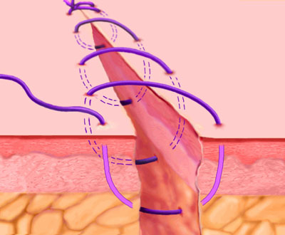

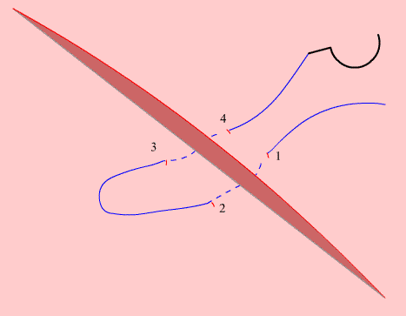
Horizontal Mattress

3. Horizontal Mattress

Good for closing wound edges under high tension, And for hemostasis.

Simple, Interrupted

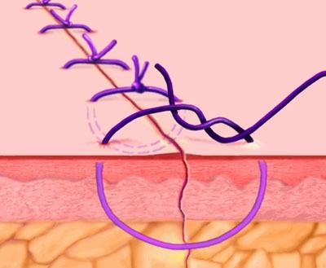

Suture Techniques

4. Vertical Mattress
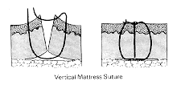
•Useful for everting skin edges •“Far-far-near-near”

Vertical Mattress

Good for everting wound edges
(neck, forehead creases, concave surfaces)

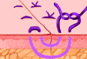

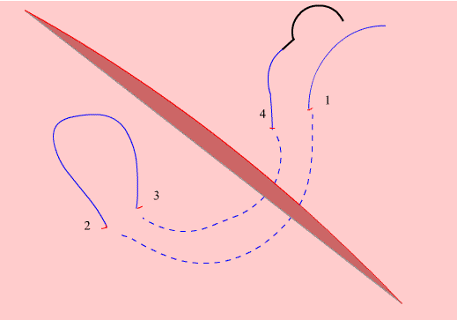
Vertical Mattress

Suture Techniques

5. Purse-string
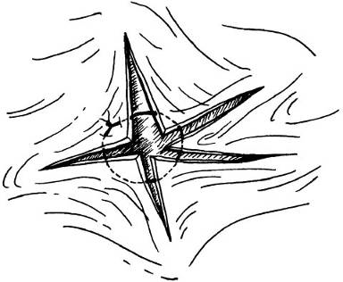
•Useful for stellate lacerations

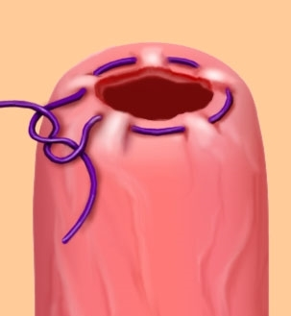

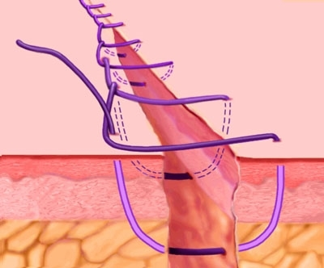

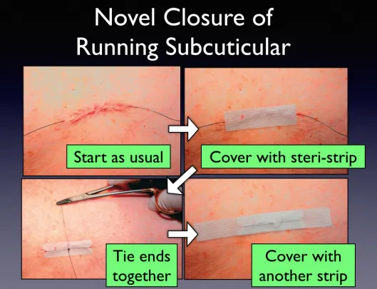
6. Subcuticular suture: cosmotic

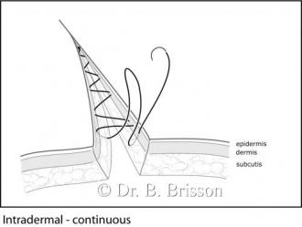

Special wound closure techniques
ci l cl s r
t c i s
1.Staplers 2.Clips. 3.Adhesive strips. 4.ZipLine.

Staples, Adhesives & Tape
t l s, si s

•Staples
•Quick, poor aesthetic result •Adhesives
•Dermabond- painless, petroleum dissolves •Tape
•Steri-strips

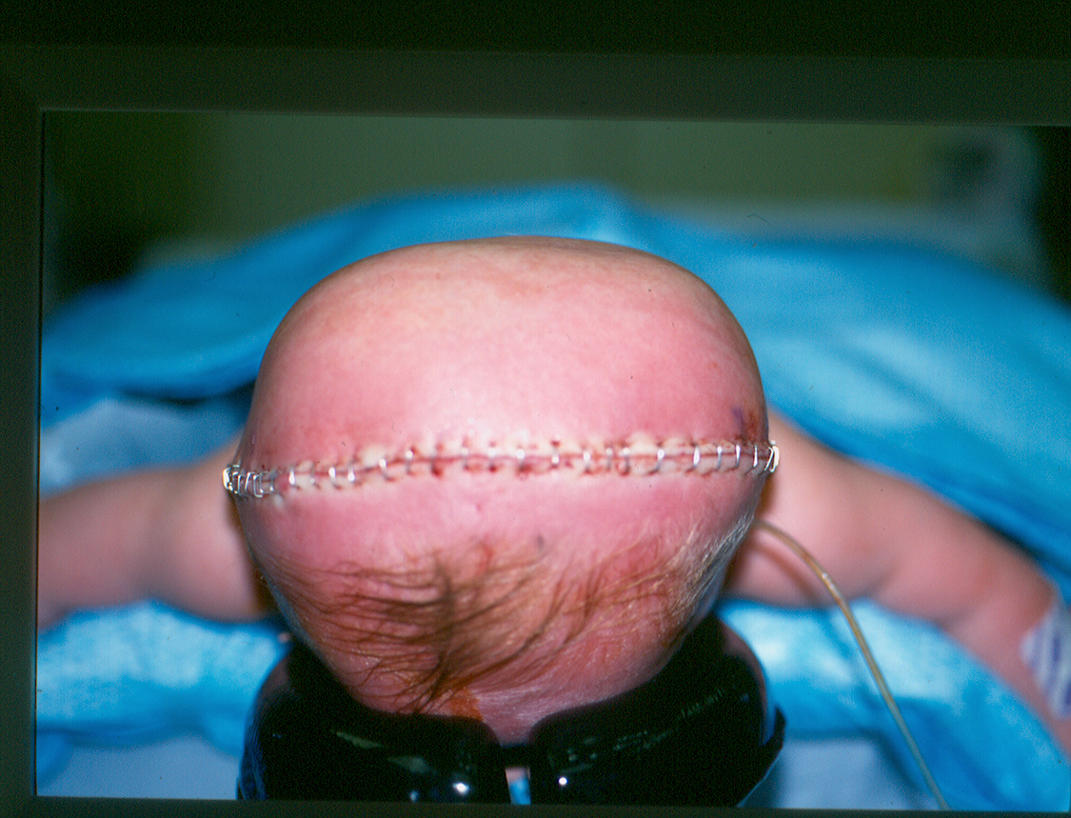
Closure using Clips

•Suture removal •Face: 3-4 days •Scalp: 5 days •Trunk: 7 days
•Arm or leg: 7-10 days •Foot: 10-14 days

Thanks for your attention !!!
s
f r
r
tt ti
!!!

