 | 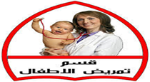 | 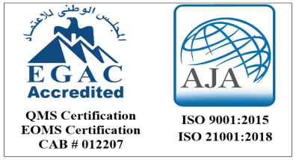 | 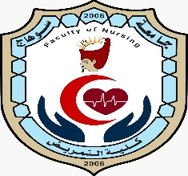
جامعة سوهاج | قسم تمريض الاطفال | كلية التمريض حاصلة على شهادتى  ISO 9001:2015 & ISO 21001:2018

CV
Personal information
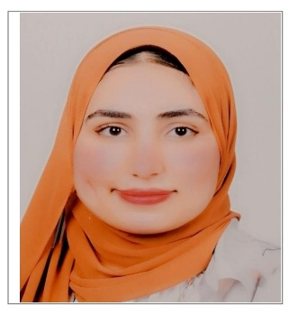
Name: Nourhan Fathy Abdelsaied Abdallah
Current job: Demonstrator at the
Faculty of Nursing, Sohag University
Date of birth: 21/3/2000
Address: sohag
Mobile number:01210309561
Marital status:
Married
Specialty: pediatric Nursing
Email: nourfathyyyy@gmail.com

Qualification
Qualification: | Specialization | University | Year
Bachelor of science in nursing | Pediatric Nursing | Sohag university faculty of Nursing | 2022-2023

