CV
Personal information  Name: Mohamed ِAbd Elrahiem Ahmed  Current job : Clinical Demonstrator at pediatric nursing  Date of birth: 4/7/1999  Religion : Muslim  Marital status : single  Address: Tahta, sohag  Mobile number:01147266920  Department : Pediatric nursing  Speciality : pediatric surgical nursing  Email: moraheem999 gmail.com@ | 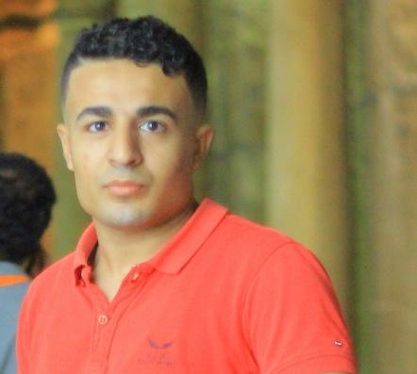
Qualification
Qualification: | University | Year
Bachelor of science in nursing | Sohag university faculty of Nursing | 2021

Participation in conferences:
- Artificial intelligence in Nursing ( education and practice)

