CV
Personal information  Name: somayaa Hassan Mohammed Elsayed  Current job : Demonstrator at faculty of Nursing , sohag university  Date of birth: 20/1/2000  Religion : Muslim  Marital status : married  Address: sohag , Tahta  Mobile number:01028251413  Speciality : pediatric nursing  Email: hsns98771@gmail.com | 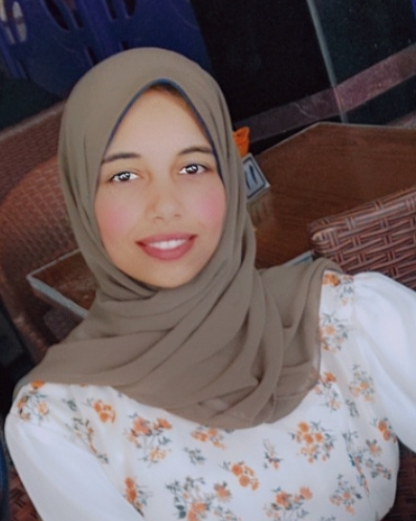
Qualification
Qualification: | University | Year
Bachelor of science in nursing | Sohag university faculty of Nursing | 2022-2023

Participation in conferences:
- Artificial intelligence in Nursing ( education and practice)

