CV
Personal information  Name:semha Abd El Nasser El Sayed  Current job: lecturer in pediatric nursing  Date of birth: 26-9-1990  Address: Nasser city -Sohag  Mobile number:01121221554-01001226585  Specialty: pediatric Nursing  specific specialty: Medical pediatric Nursing  Email: : - dr.semhaabdelnasser@yahoo.com | 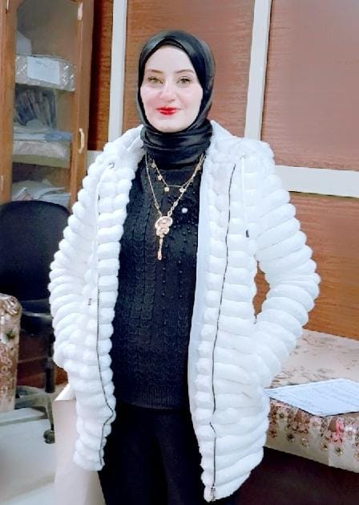
Qualification: | Specialization | University | Year
Master of Pediatric Nursing | Pediatric Nursing | Assiut University | 2020
Dectorate Degree in Pediatric Nursing | Pediatric Nursing | Sohag University | 2025
Subjects that I teach:
Subject | Grade | Semester | Year
Practical Nursing for obstetric gynecological Health | 3 | 1st | 2024
Practical pediatric Nursing | 3 | 2nd | 2024
Methods of research  مهارات التوظيف | 3 | 1st | 2025
Theory of pediatric Nursing | 2 clinical institute  nursing | 1st | 2025

Participation in professional Training Courses :
-Self-assessment and preparation of self-study for academic programs .
-Safety and security requirements in light of quality assurance standards .
-Effective presentation skills .
-German language course .
-Internal audit course .

Participation in conferences:
- Nursing students readiness to digital transformation towards universal
- Artificial intelligence in Nursing “Education and practice”

Local published research
- Effect of story telling on reducing nausea and vomiting of preschool child undergoing chemotherapy.
- Family Socioeconomic Status on Wasting and Stunting among their Preschool Children
Other activities
Participation in the medical convoy of human and veterinary medicine and the College of Nursing to Al-Farsiyya village in Saqalta Center.
Excellence points
-Certificate of thanks and appreciation for working as ISO review team leader
-Certificate of thanks and appreciation presented by the children's department for completing the tasks assigned to it

