Personal information  Name: Asmaa Ragab Abd El Mobdy Nour EL Dein  Department: Pediatric Nursing  Current job: Demonstrator at Pediatric Nursing  Date of birth: 6-2-1991  Address: Sohag – Governorate Area – East District, behind the University Hospital –Al-Ter'a Al-Mardouma Street – Abu Hesham Street  Marital status : Married.  Religion: Muslim.  Mobile number: 01010855448  Specialty: Pediatric Nursing  Email: asmaaragab1000@gmail.com | 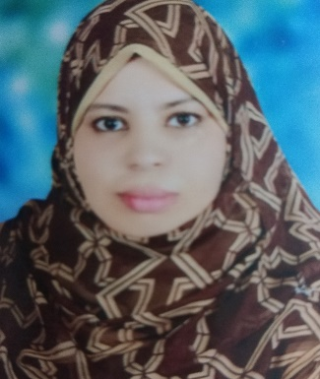
CV

Title of master thesis:
Assessment of Nurses Performance Regarding Application of Preventive Measures of Hepatitis C Virus Infection Among Children undergoing Hemodialysis.

- تقييم أداء الممرضات تجاه تطبيق الإجراءات الوقائية عن الإصابة بفيروس التهاب الكبد الوبائي (ج) بين الأطفال الذين يخضعون للغسيل الكلوي الدموي
-

