CV
Personal information  - Name: Asmaa Housny Abd Elaziz Ibrahim  - Current job : Assistant lecturer of Pediatric Nursing  - Date of birth : 7/9/1997  - Address :Sohag, Egypt  - Mobile Number: 01227363371  - Specialty :Pediatric Medicine Nursing  - Email: asmaahousny38@gmail.com | 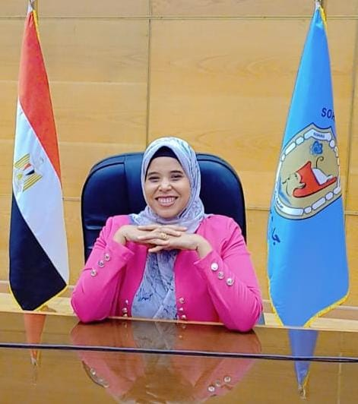
Educations Qualification:
Qualification: | Specialization | University | Year
BSc | Nursing Science | Sohag | 2019
Master in pediatric nursing | Pediatric Medicine Nursing | Sohag | 2025
Academic Career Progression:
Job | Year |  | University
Demonstrator of pediatric nursing | 2020 | Sohag | university
Assistant lecturer of Pediatric Nursing | 2025 | Sohag | university
Research published
Assessment of Parent`s Satisfaction Related to Nursing Care Provided to Their Children
تقييم رضا الوالدين فيما يتعلق بالرعاية التمريضية المقدمة لاطفالهم
Experiences in the Field of Total Quality Management Systems:
-Member of administrative body Standard
- quality Coordinator, Pediatric Nursing Department - Faculty of Nursing -
Sohag University
-Member of Scientific publishing Unit- Faculty of Nursing - Sohag University
Attendance and participation in conferences:
Has attended the Fourth Student Conference- -Faculty of Nursing - Sohag University on 6\3\2023 with scientific research under the title “ Nursing
- students readiness to digital transformation towards universal health insurance system”
- Has attended the 5th International Scientific Conference of Faculty of Nursing- Sohag University on 27to 28/12/2023 “Climate Changes and
Health Nursing Vision”
- Has attended the 6th International Conference - Faculty of Nursing- Sohag University as a guest speaker on 6\11/2024 Artificial Intelligence in Nursing “Education and Practice”
Participation as a trainee in training programs:
- Attending and passing the University Teacher Preparation course at 2021
-Attending a workshop (competencies and preparing course specifications) on 2/8/2021
- Attending a workshop (Research Methodology: What nurses need to know) on 12/28/2023
- Attending and passing the quality course entitled “Concepts and Basics of Quality Assurance” during the period 2-3, August 2023
- Attending and passing the quality course entitled “Establishing an Internal Quality Management System” from 7-8, August 2023 .
- Attending and passing the Anti-Corruption Course during the period 6/8/2023 to 7/8/2023
- Attending and passing the Teaching and Learning Strategies Course during the period 9-3-2024
- Attending and passing a 36 hour English Language Proficiency Course held at Sohag Language & Translation Center with a percentage of 98% on 18/7/2024
- Attending and passing The Fundamentals of Digital Transformation Certificate in 2024
- Attended a workshop: “Ethics of Scientific Research and Intellectual
Property Rights” at the Faculty of Nursing - Sohag University on 27, February 2024.

